NORTH CAROLINA BOARD OF EXAMINERS
FOR ENGINEERS AND SURVEYORS
4601 Six Forks Road, Suite 310
Raleigh, North Carolina 27609

COMPLAINT FORM
Complainant | Brian Ceccarelli, B.Sc. Physics, AM.ASCE, IA.ITE  4605 Woodmill Run  Apex, NC 27539  919-815-0126  canute@redlightrobber.com  I know the physics, the math and the local and national engineering specifications for the yellow change interval. I know 100 years of history behind these standards. I also know the profit-incentives, legal problems and political motivations behind the red light camera business.
Complaint
Against

Witness | Joseph Shovlin, Ph.D. Physics
Witness | Johnnie Hennings, P.E., B.Sc. Mechanical Engineering  License: 039281
Submittal Date:

Complaint Specific to Engineer

General Engineering Complaint
My engineering complaint is very simple. My complaint is common to all traffic engineers:
Newton’s second law of motion is F = ma where a = Δv/Δt. But traffic engineers use a = Δv/2Δt to set the yellow light duration. The “2” in the denominator is the problem.
The 2 as applied to traffic signals means that the yellow duration is half the time it takes a driver to stop. Half. Like most traffic engineers, Mr. X does not possess the knowledge of the physical sciences to discern its implication. Generally speaking, traffic engineers lift the Formula from a book without ever noticing the crazy “2”. They just use the formula. The “2” causes drivers a cornucopia of problems which I itemize later, problems which engineers blame on drivers.
The following is the relief I seek from the Board of Engineers. I seek the Board issuing the statement:
The lengths of the yellow change interval durations on the signed and sealed signal plans of record are not in accordance with NCGS 89C. The traffic engineers who have signed the signal plans have not complied with their license by using methodologies which oppose the laws of the mathematical and physical sciences. The yellow change interval setting methodologies are not engineering practices.
- By not knowing physics, the engineers have not given the driver the time to decelerate (v/a) on route to the intersection necessary for traffic movements like turning or avoiding hazards.

- By not knowing mathematics, for unimpeded straight-through traffic movements; that is movements for which the ITE yellow change interval Formula was invented, the engineers improperly endorse zero-tolerance enforcement of red light running ordinances in spite of the fact that Formula embeds human factors’ such as perception/reaction time and decelerate rate. As such, the yellow change interval has a computable error of several seconds.

- The engineers did not comply with other physics and engineering requirements listed in this document.

The Board of Engineers in North Carolina also has power to affect the City’s red light camera policy.

- Because the North Carolina General Statutes state that the yellow light durations must be set by engineers in compliance with NCGS 89C, and because the Board rules over issues of NCGS 89C, the Board can seek a cease and desist order to halt the City’s red light camera program.

It may be possible for the Board to compromise with the City. If the City insists on continuing its red light camera (RLC) program (because of contractual obligations with the red light camera vendor) and while the NCDOT does not lengthen the yellow lights, then the Board can force the City to increase the RLC system’s grace time (aka, delay) lest drivers continue to be punished unfairly. The grace time must be increased by at least v/2a, where v is the greater of the speed limit or the 85th percentile speed, and where a = 11.2 ft/s.² v/2a is the amount of time the yellow change interval must be lengthened so that valid traffic movements can legally enter the intersection.

- The City must add more time to v/2a when the intersection has other problems. For example at Peace at West Street in Raleigh, there is a train trestle blocking the view of the traffic signal for two seconds for vehicles inside the critical distance. The engineer also did not compute the grade of the road properly for she did not know where to measure v.

- The City thinks it has ultimate authority of using red light cameras. It does not. The NCDOT does. If the City refuses to remove its red light cameras or refuses to increase the red light cameras’ grace times as specified above, then under Section 1A.07 of the NC MUTCD, the NCDOT has the authority to remove the cameras immediately. A red light camera is a “traffic control device”-- so the cities and camera vendors bill them. The cameras are supposed to control traffic by modifying driver behavior. All traffic control devices fall under the auspices of the NCDOT, not the local city government or the red light camera vendor. NCDOT engineers are in control of the red light cameras and the Board of Engineering has ultimate control of the NCDOT engineers.

Every traffic engineer in the State is guilty. Had the engineer bothered to listen and apply, I would not be bringing this complaint to the Board. For 5 years now traffic engineers have refused to crack open a physics book and see the problem for themselves. They stick stubbornly to established traditions without questioning their origins.
“It is hard to make a man understand something, especially when his salary depends on him not understanding it.” -- Upton Sinclair
Meanwhile city councils close the circle of entrapment aided by the efficient technology of the red light camera.
The status quo must change.

Glossary
To acquaint you with the engineering details of the problem, I first present a glossary of traffic engineering terms. Secondly I describe the core problem. It takes an understanding of the glossary words to understand the problem. I describe the core problem with animations. The animations are worth a 1000 words. Thirdly I present a list of infractions committed. I follow the list with a narrative forecasting how the Engineer, upon your investigation, will attempt to cover up his transgressions. Last of all, I supply a list of additional supporting documents.
Yellow Change Interval (p. 756, top 2nd column): is the amount of time the traffic signal indication is a steady yellow light whose length is that amount of time it takes a driver to traverse the critical distance.
Critical Distance (p. 114 bottom): Also known as the safe and comfortable stopping distance. It is the distance the driver travels at his initial speed while he perceives and reacts to a light change from green to yellow, plus the distance it takes the driver to brake to a stop. Divide the critical distance by the initial speed and you get the yellow light duration as computed by the Formula. The car going straight in this animation shows the relationship.
Formula: is the ITE yellow change interval Formula. The Formula computes the yellow change interval for the case when the driver traverses the entire critical distance at maximum allowable speed. If the average speed of the driver falls under maximum allowable speed, the driver can involuntarily run a red light.
ITE Yellow Change Interval Formula
$${Y= t}_{p }+ \left[\frac{v}{2(a+Gg)}\right]$$

Variable | Description
Y | Yellow light duration
t_{p} | Perception/reaction time constant
v | Approach speed, Maximum Allowable Speed
a | Safe comfortable deceleration of a vehicle
G | Earth’s gravitation acceleration constant
g | Grade of the road in %/100. Downhill is negative.
a + Gg | Effective deceleration of vehicle

Maximum Allowable Speed: must be the speed limit or by engineering guidelines, at least the 85th Percentile Speed, whichever is greater. The 85th percentile “v” is that speed of freely-flowing vehicles at which 85% of the vehicles travel slower than “v” and 15% travel faster than “v”. The Engineer usually uses the term “approach speed” instead of maximum allowable speed. Physics tells us that “v” is the speed of the vehicle at the critical distance upstream from the intersection stop bar.
Dilemma Zone Type I: A region upstream from the intersection where if the driver is in it when the light turns yellow, by the laws of physics the driver neither has the distance to stop nor the time to proceed into the intersection legally.
Dilemma Zone Type II: Also called an indecision zone. A viable stop or go does exist, but within a region upstream from the intersection the driver does not know what it is.
Stop Bar: The white solid line on the road which marks the entry line into the intersection.

Core Problem
These animations illustrate how traffic engineers force drivers to run red lights.
1 |  | Left-Turning Driver Forced to Run Red Light, Case 1  The light turns yellow just before the left turn driver brakes in preparation to turn. The protected left turn yellow is 3 seconds while the straight-through is 4.5 seconds. The NCDOT justifies this practice because it only considers queued cars in a left turn bay. Engineers measure only the speed of cars who have been waiting to turn, plugging that number into the formula, albeit the formula which does not apply to turning movements anyway.
2 |  | Left-Turning Driver Forced to Run Red Light, Case 2  The light turns yellow just after the drivers cross the critical distance line. Neither driver can stop safely and comfortably at this point. Both must proceed. The left-turning driver must run a red light. Note that neither left turn nor straight-through yellow is long enough for the left-turning driver. The straight-through driver is okay because he does not slow down.
3 |  | Right-Turning Driver Forced to Run Red Light  The right-turning driver has the same problem yet to a greater extent than the left-turning driver. The more a driver needs to slow down, the worse the problem gets.
4 |  | Straight-Through Driver Forced to Run Red Light  The light turns yellow just after the drivers cross the critical distance line. Slowing down for any reason, whether to turn or to avoid hitting a car pulling out of a gas station, causes the drivers to run a red light. The Formula only applies to a driver who can traverse the critical distance unimpeded to the intersection without decelerating for any reason, and who knows exactly where the critical distance line is.

Johnnie Hennings, P.E., created the animations to scale and such that they model the laws of physics. He used the computer program ARAS 360. The animations represent a typical 45 mph level road in North Carolina using the yellow light durations set to NCDOT specification. All signalized intersections in NCDOT are supposed to meet this specification. Though the animations are for a 45 mph road, the same problems arise for roads of every speed limit above 10 mph. To compute the exact locations on the road of the critical distance and “begin slow” lines, and to compute how much time it takes for the car to traverse the critical distance, look at this spreadsheet and the math behind the spreadsheet.
The red light running in the animations are all consequences of the crazy “2”. According to the Town of Cary’s red light camera data, the “2” is responsible for 92% of all red light running. The remaining 8% is mostly caused by other traffic engineering blunders or limitations.
Proof – Data Collection
I should be able to end my complaint before getting to this section. All I am asking the Board to do is to acknowledge that the “2” in the Formula conflicts with Newton’s Laws. I am asking the Board to acknowledge that the “2” is the cash cow of the red light camera industry and the perpetrator of safety problems. I hope that Board of Engineers accepts that Newton’s Laws are true and immutable. I no longer assume even that because I have legally deposed the likes of Lisa Moon (p. 22-3 to p. 23-7), who is in charge of over 750 signalized intersections in North Carolina, who neither knows Newton’s Laws nor thinks that Newton’s laws apply to the motion of objects such as cars.
I do in fact have data to prove Newton’s Laws are upheld in North Carolina. The Town of Cary gave me the raw data of over 140,000 red light camera tickets. For each ticket I have the data regarding the time of the violation, the amount of time the driver entered the intersection after the light turned red, and the lane type (left, straight, shared-right, dedicate right lane). Together with the yellow change interval from the signal plans, my colleagues and I analyzed the data.
The analysis of the data shows that 1) the laws of physics pertaining to objects in uniform motion with constant acceleration apply and that 2) traffic engineers’ signal plans fail to comply with these laws of physics. Below are four graphs. The graphs are of one intersection, Walnut St at Meeting Pl. in Cary. These graphs exemplify what happens at every intersection.
Each graph is a plot of Vehicles / Day Running the Red Light (y axis) versus Time into Red (seconds).
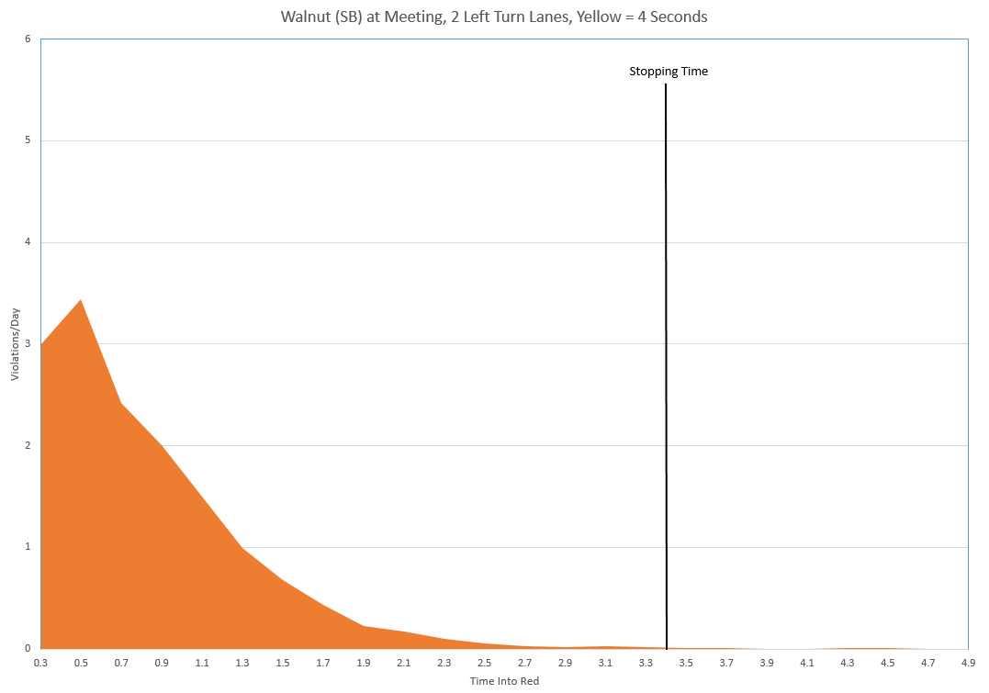
Subtract one second from the yellow light duration above and you get the graph below:
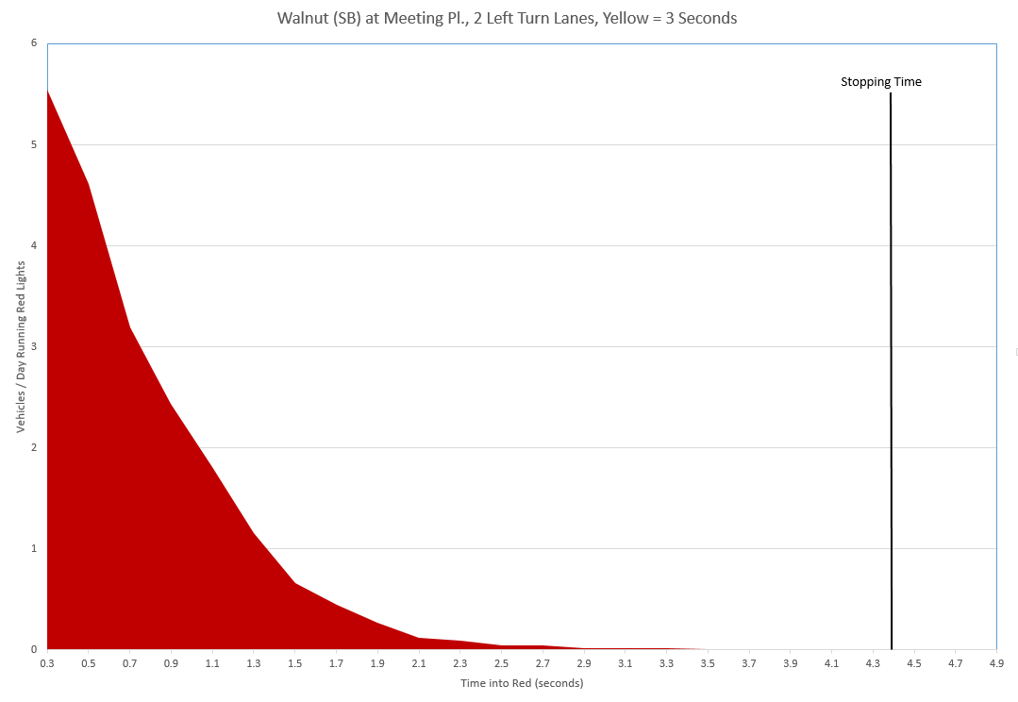
The next graph is for the same intersection, at the same scale as the left-turn graphs, but for the 2 straight through lanes. As you can see, the Formula is designed for straight-through lanes:
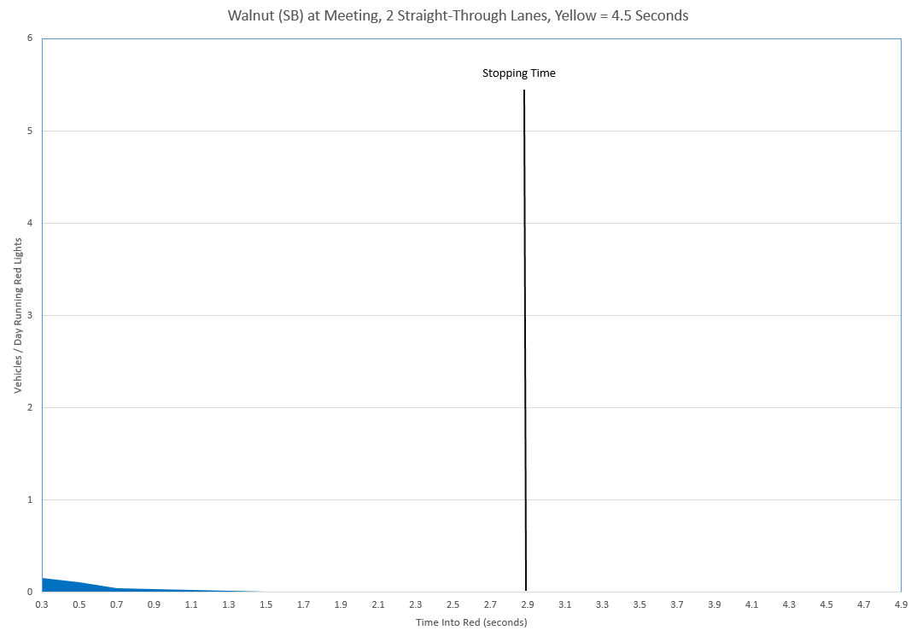
Below is same straight-through lanes as above but scaled to fit the entire y-axis. Like the turning lanes, the straight-through lanes show a curve which ends at the stopping time. Some vehicles decelerate on route to the intersection because of hazards, unexpected lane changes, etc:

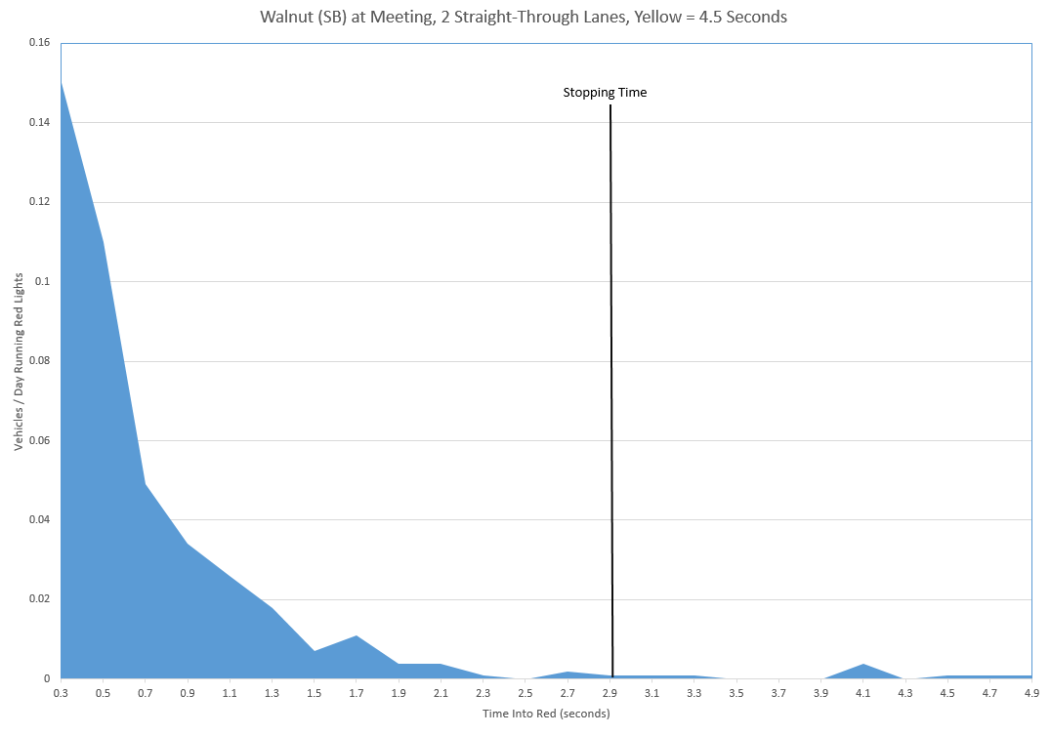
Minor changes in the yellow light duration radically affect the red light running rate. I also have a plot of counts vs. time for every red light camera intersection in Cary. Every time Cary decreases or increases the yellow, the counts radically spike or dip to permanent new levels. Even a 0.1 second decrease in the yellow increases the violation rate by 50%.
The graphs show three conclusions:
- Changing the yellow light duration even by a little radically affects red light running.

- The Formula fails for left turns. In spite that traffic flow in the turning lanes is about 80% less than that of straight-through lanes, the left turn lanes have 20 times more violations.

- All traffic movements require up to the Stopping Time to enter the intersection. The tail of the curve of red light runners drops to zero once Newton’s 2nd Law is satisfied—at the time it takes a driver to stop. Stopping Time is Newton’s basic equation of motion (t = v/a) plus the perception/reaction time. The amount of time drivers run red lights is the difference between the Stopping Time and what the traffic engineers give for a yellow duration.

Violations’ Checklists
I group the Engineer’s violations into 5 categories.
- Physics Violations
- Math Violations
- General Engineering Violations
- MUTCD Violations
- Ethics Violations

Physics Violations
The Engineer is guilty of the items that are checked or endorses ‘E’ other engineers performing them.
.
 | 1. | The Engineer does not know the meaning of the Formula.
 | 2. | The Engineer does not know that the Formula itself by its very nature creates dilemma zones, areas upstream from the intersection where if the driver is in it when the light turns yellow, the driver does not have a solvable stop or go decision, or there is a solution but the driver does not know what it is. A different Formula (one without the 2 in the denominator) would remove dilemma zones altogether. It would always give the reasonably perceptive driver the solution of slowing down without penalty. The Engineer does not know this is possible.
 | 3. | The Engineer misapplies the Formula to traffic turning left where the maximum allowable speed is greater than the intersection entry velocity. Dr. Alexei Maradudin explicitly mentions this misapplication, as well as 4 through 12, in this letter. All of these misapplications force drivers to run red lights.
 | 4. | The Engineer misapplies the Formula to traffic turning right where the maximum allowable speed is greater than the intersection entry velocity.
 | 5. | The Engineer misapplies the Formula to traffic executing a U-turn. A U-turn requires almost double the time computed by the Formula.
 | 6. | The Engineer misapplies the Formula to signals at two close-by intersections. Traffic may have to slow down for the second light (or traffic waiting for the second light) before arriving at the first light.
 | 7. | The Engineer misapplies the Formula to traffic proceeding straight that slows down for vehicles entering or egressing to and from business entrances and side-streets near the intersection.
 | 8. | The Engineer misapplies the Formula to traffic slowing down because of traffic density in the intersection makes it impossible to continue at the initial velocity when entering the intersection.
 | 9. | The Engineer misapplies the Formula to traffic slowing down because the maximum allowable speed on the far side of the intersection is less than that on the near side.
 | 10. | The Engineer misapplies the Formula to traffic slowing down because vehicles are changing lanes in front of them.
 | 11. | The Engineer misapplies the Formula to traffic slowing down for railroad tracks, bumps or potholes near the intersection.
 | 12. | The Engineer misapplies the Formula to traffic slowing down for hazards like pedestrians suddenly entering the highway near or in the intersection in front of them.
 | 13. | The Engineer misapplies the Formula to traffic slowing down for a speed table, hump or bump (in UK, a “ramp”) near the intersection.
 | 14. | The Engineer misapplies the wrong speed into the Formula. The NCDOT erroneously plugs in “v” as measured at the stop bar instead of at the speed limit’s critical distance.
 | 15. | The Engineer plugs in the wrong speed into the Formula. The Engineer plugs in “v” which is not the 85th percentile speed but rather the speed limit or less.
 | 16. | The Engineer plugs in the wrong speed into the Formula. The Engineer plugs in “v” for a turn lane which assumes cars are in a queue (p. 8).
 | 17. | The Engineer plugs in the wrong grade into the Formula. The NCDOT plugs in “g” as measured at the stop bar (p. 15), not the average grade of the road throughout the critical distance.
______ | 18. | The Engineer asserts that he can ignore the Formula and set the yellow shorter than the Formula. (The Engineer altogether ignores physics.)
 | 19. | The Engineer believes that a deterministic equation (p. 8) (and here) cannot exist to model all reasonable traffic movements.
 | 20. | Though responsible for the enforcing the motion of traffic at signalized intersections in Raleigh, the Engineer does not know Newton’s Laws of Motion (p. 22-3 to p.23-7).
 | 21. | The Engineer believes that Newton’s Laws of Motion do not apply to the motion of vehicles (p. 22-3 to p.23-7).
 | 22. | The Engineer has written or uses a red light camera before/after study to justify red light cameras. The before/after study does not invoke the scientific method; therefore, the results are invalid. A conclusion from a statistical analysis without the scientific method is at best specious. The study may be pleasing to the eye but it is deceptive. The engineer does not know general science to discern the issue.

Mathematics Violations
The Engineer is guilty of the items that are checked or endorses ‘E’ other engineers performing them.
 | 1. | The Engineer does not know the mathematical technique of error propagation. For example, the Engineer declares that the yellow change interval is 4.5 seconds, but the interval should really be 5.3 +/- 2.3 seconds. Because the variables plugged into the equation have an equally valid range of values, the yellow change interval has an associated range.  Because the Engineer does not know this, he leads law enforcement to believe that this yellow change interval is exact.  In general, in spite that the Engineer sets yellow light duration knowing in advance that it does work for a large minority of law-abiding drivers, he endorses zero-tolerance law enforcement.

General Engineering Violations
The Engineer is guilty of the items that are checked or endorses ‘E’ other engineers performing them.
 | 1. | The Engineer designs for traffic flow, traffic safety and legal movement--in that order. This priority is crucially important to understand because it underlies the Engineer’s motivations. But this priority violates the statutory mandate of a professional engineer. The statute requires the Engineer to safeguard life, health and property, not to safeguard the quickest means to the destination.  Traffic flow, safety, legal movement . . . pick any two. When flow is the goal (which it always is), safety and legality cannot happen at the same time. To increase flow, the engineer maximizes the green light time all drivers see in a given signal cycle. The only time from the signal cycle the Engineer can transfer to a green light is that from the yellow or the all-red clearance interval. So to accomplish his flow goals, he often trades yellow for green. His trade from yellow to green is a trade from legal motion to flow.  An intersection being safe does not mean that the intersection allows traffic to move legally. Increasing flow at the expense of yellow causes more and more vehicles to run red lights. But the additional red light incursions do not automatically cause additional crashes. There does come a point where too little yellow causes additional rear-end collisions and too little total yellow plus all-red clearance will cause additional side-collisions.  Example. In January 2010 at Kildaire Farms Rd (NB) at Cary Parkway, the NCDOT decreased the left turn yellow 1 second while increasing the all-red clearance ½ second (p. 10). The crash rate remained the same but the red light violations instantly surged from 60/month to a permanent 450/month. Because the new sum of the yellow and all-red intervals is ½ second less per signal cycle than before, the green light is ½ second more per signal cycle. This repetitive extra ½ second for the green makes traffic flow more efficiently. The ultimate goal of the traffic engineer. The engineer knows that engineering is responsible for increasing red light running 700% (p. 51:21 and on), but insists that drivers suffer for it (p 108:16).
 | 2. | The Engineer ignores the yellow change interval requirements for commercial vehicles (p. 5) or vehicles pulling trailers or boats. The Engineer always assumes that approaching vehicles are solo passenger sedans. The Engineer forces a greater percentage of school buses, public buses, tractor trailers and vehicles hauling trailers/boats/other to run red lights. Because of their weight and concerns over jack-knifing and shifting cargo, these vehicles need about 2 seconds more yellow (p 88, Table 3, 85th Percentile requirement for Tractor-Trailers).
 | 2a. | The Engineer ignores the extra yellow time requirements for vehicles with air brakes (p. 5-9). Traffic engineers always shorts a yellow by about 0.75 seconds for such vehicles.
 | 2b. | The Engineer uses 11.2 ft/s² for deceleration all the time. At best, commercial vehicles with empty tractor-trailers have a safe and comfortable deceleration of 8.0 ft/s² on wet pavement (p. 48).
 | 2c. | The Engineer uses 11.2 ft/s² for deceleration all the time. Public buses and school buses have a maximum of deceleration of 7.4 ft/s². Quicker decelerations result in knocking forward-facing standard passengers off their feet.
 | 3. | The Engineer plugs in 11.2 ft/s² for deceleration. That rate is aggressive and applicable only for emergency stopping. (It is the 90th percentile rate for emergency stopping: AASHTO Green Book, 2011, p3-3). Engineer expects drivers to slam on the brakes for a normal yellow light. Most States use 10 ft/s²--the 50th percentile for comfortable stopping.
 | 4. | The Engineer plugs in 11.2 ft/s² for deceleration. Any rate greater than 8.0 ft/s² implies dry pavement. When rain makes the pavement wet, the friction between road and tire decreases thus making a driver brake harder to achieve the same deceleration. Whether it is comfortable for a driver to brake harder varies by driver and vehicle.
 | 5. | The Engineer assumes a perception/reaction time of 1.5 seconds. 1.5 seconds is the 85th percentile time for a very simple intersection. AASHTO recommends an 85th percentile of over 2.5 seconds for an intersection of average complexity.
 | 6. | After the yellow indication terminates, the Engineer does now allow the slowest driver the time to traverse the intersection. The Engineer uses the maximum allowable speed instead of the intersection traversal speed of a vehicle turning left. The Engineer shorts the all-red clearance time.
 | 7. | When setting the yellow change interval, the Engineer ignores the fact that a train trestle blocks the signal head for 100 feet within the critical distance upstream from the intersection. For 2 seconds when it is most critical, the driver cannot see the signal head. The Engineer did not add 2 seconds to the yellow change interval to compensate.
 | 8. | The Engineer did not put back-plates on the signal head. Therefore there is no contrast between signal and background. The driver has a hard time seeing the light.
 | 9. | The Engineer did not put back-plates on the signal head and the roadway stretches East and West such that the brightness of the Sun masks the signal indications in the morning and evening hours.
 | 10. | The Engineer created a visual problem for drivers at the intersection. Straight-through signals are in front of the left turn lanes.
 | 11. | The Engineer created a visual problem for drivers at the intersection. There is a separate right turn lane but there is no signal head in front of this lane.
 | 12. | The Engineer created a visual problem for drivers at the intersection. The signal head is not in line-of-sight throughout the entire critical distance.
 | 13. | The Engineer set the max-green too short. The green light does not last long causing an unreasonable bottleneck at the intersection. Drivers get frustrated and run the red light because of the unreasonableness.
 | 14. | The Engineer did not use a loop to detect traffic waiting at the stop bar. It takes too long for the light to turn green and drivers must wait for nothing.
____ | 15. | The Engineer placed the actuation sensors at the wrong distances from the intersection. Actuation sensors detect the presence, number and/or speed of vehicles. Some sensors should be placed at the stop bar. Some sensors should be placed in the dilemma zone (the zone created by the Formula) whose purpose is to delay the yellow until the vehicles are no longer in the zone. Some sensors detect approaching traffic and turn the light green before the vehicle has to slow down. Because the Engineer does not know physics, the Engineer placed these sensors in the wrong location.
 | 16. | The Engineer placed the red light camera detector loops in the intersection, not before the stop bar. Vehicles enter the intersection legally on a yellow. The light turns red and the vehicles pass over the detector loops. Drivers receive a ticket for running a yellow light.
 | 17. | The Engineer did not mark the stop bar properly. The stop bar is not clearly defined, or looks different than the stop bars on the other approaches to the intersection. The stop bar may also be worn off. Drivers are confused about where exactly to stop.
 | 18. | The Engineer set up the red light camera such that it gives tickets to people running yellow lights.
 | 19. | The Engineer set his yellow change intervals according to the wrong speed limit. The information on the traffic signal plan conflicts with the speed limit order of the DOT.
 | 20. | The intersection is under construction. The lights are not functioning properly but the Engineer failed to turn off the red light cameras. The Engineer violates the engineering-first, enforcement-second rule.
____ | 21. | The State (e.g., Louisiana, West Virginia, Rhode Island, Tennessee, Oregon) has a restrictive yellow law and that requires the yellow light to be long enough for the driver to traverse the critical distance and clear the intersection. But the Engineer treats the yellow change interval as if the State has a permissive yellow law. The Engineer shorted the yellow change interval by not adding to it the all-red clearance interval. The Engineer designs the intersection so that conflicting traffic can be in the intersection at the same time.
 | 22. | The left turn lane has a permissive green phase but oncoming traffic make turning too dangerous. The left turn lane should only have a protected left turn green.
 | 23. | The left turn lane has a permissive green phase. It is inconsistent. All other intersections nearby along the same highway do not have a permissive green phase. They only having a protected phase.

The Manual of Uniform Traffic Control Devices Violations
The Engineer is guilty of the items that are checked or endorses ‘E’ other engineers performing them.

 | 1. | For the same yellow light indication, the Engineer violates the MUTCD by setting it to different durations depending whether the signal phase is in protected turn mode or permissive mode. This creates an unpredictability to the length of the yellow light. A driver can see 4.5 seconds, go around the block and then see 3 seconds from the same yellow indication. This practice violates MUTCD 4D.17-07, 4D.26-09, 4D.04-3B, 1A.13-258.
 | 2. | The MUTCD 4D.26-01 standard requires the yellow light in the yellow change interval to be a steady yellow. Only when the yellow light reaches full luminosity can one consider the yellow light steady. The Engineer does not discern between the traffic signal plan’s values for the yellow change intervals and what appears in real world. The signal plan’s values are actually the yellow light electric circuit-on times, not the real yellow change intervals.  Once the traffic controller computer turns on the yellow light circuit, it takes about 0.2 seconds for relays to fire, rectifiers to condition the current, and the bulbs to illuminate. When the traffic signal plan says the yellow change interval is 3.8 seconds, the fully-illuminated yellow the driver sees is 3.6 seconds.  A driver’s decision to stop or go hinges on the length of the steady yellow light. 0.2 seconds is significant to the legal motion of traffic. Red light camera data shows that 20% of drivers run the red light within 0.2 seconds of the light turning red.  By not discerning steady in the MUTCD requirement, the Engineer makes an engineering violation. The Engineer does not set the yellow light long enough so that the steady portion of the yellow indication equals or exceeds that of the Formula.
 | 3. | For the same yellow light indication, the Engineer violates the MUTCD by using a traffic controller which randomly varies the yellow light duration over +/- 0.1 seconds for different signal cycles. This happens when the Engineer uses LEDs for the lights but the electric current from the traffic controller to the LEDs is AC. Because LEDs are DC devices, a rectifier converting AC to DC has to be put in the circuit between the traffic controller and the LEDs. Rectifiers contain electrolytic capacitors. Capacitors take time to charge. The phase of AC sinusoidal wave form coming from the traffic controller determines how fast the rectifier’s capacitors charge and thus its turn-on point. Because each signal cycle begins at a different AC phase, this gives the yellow light duration a randomness. The hardware is faulty by design. The traffic controller should send DC directly to the LEDs. By using this type of traffic controller, the Engineer violates MUTCD 4D.17-07, 4D.26-09, 4D.04-3B, 1A.13-258.
 | 4. | In the turn lane phasing of the intersection, the Engineer did not follow the steady yellow arrow by a steady red indication. Instead a flashing yellow arrow appears immediately after the steady yellow arrow. This violates MUTCD 4D.05 (03) B.3. A steady red light must follow any steady yellow light. Without the all-red clearance interval, turning vehicles can be in the intersection at the same time conflicting traffic has the right-of-way.

Ethics Violations
The Engineer is guilty of the items that are checked .
 | 1. | The Engineer fails to tell law enforcement of the error built into his calculation of the yellow change interval. He endorses law enforcement to punish his imprecise calculations with zero tolerance. See Mathematics Violation 1.
 | 2. | The Engineer fails to tell law enforcement that using the Formula demands that some drivers must accelerate to beat the light. The Formula’s demand conflicts with the DMV Driver Handbook’s (p. 69) command to not beat the light. Some municipalities use their red light cameras as speed cameras. By legal definition, the Engineer has caused entrapment.
 | 3. | The Engineer allows red light cameras to go up in spite of the fact that the presence of red light cameras takes the driver’s attention away from the road. The driver is over concerned with the financial consequences for running a red light than paying attention to hazards.
 | 4. | The Engineer knew about a failure in the traffic signal plan of record. The failure even violates the DOT’s own specifications. The Engineer lied to me and allows the public to take the penalty for the failure so that his employer, the municipality or the NCDOT, won’t be held responsible.
 | 5. | By design the Engineer tunes the yellow change interval according to the ITE recommendation of allowing up to 3% of drivers to run red lights (p 30). ITE states that increasing the yellow time can reduce the percentage to near 0% but ITE simultaneously subscribes to the fact that the DOT’s goals trump those of law enforcement. Therefore the Engineer’s practice is to force drivers to run red lights but the Engineer does not inform law enforcement of the conflict of interest.
 | 6. | The Engineer has committed fraud by omitting a persons’ legal rights in legal documents (red light camera citations) in order to secure payment for the red light camera company and/or City. Because the amount of the fraud totals millions of dollars, the Engineer committed a felony.
 | 7. | The Engineer has committed extortion by overstepping the State’s enabling statutes. He forces or encourages drivers to incriminate themselves and/or sign affidavits beyond the statutes’ mandates. He does this is order to secure money for the red light camera company and/or City.
 | 8. | In full knowledge that he or his fellow engineers were responsible for sudden permanent increases in red light running, the Engineer endorses innocent motorists to take the penalty for engineering changes. The Engineer washes his hands of his contribution and blames the City for penalizing such motorists.
 | 9. | The Engineer knows the posted speed limit is 45 mph. The Engineer allows the yellow change interval to be set to around 3 seconds, a MUTCD minimum, which algebraically makes the speed limit 23 mph. The Engineer acknowledges the engineering discrepancy but endorses law enforcement to punish drivers for it (p 63:7).
 | 10. | The Engineer increased the overall signal cycle time. The traffic signal changes to red less frequently during the day giving drivers fewer opportunities to run a red light. The effect causes a dramatic decrease in the red light running violation rate.  The problem is not the change to the signal cycle time. It is the Engineer’s failure to inform the city and police that it was the signal cycle time change which induced the decreased violation rates. The Engineer allows the city to believe the decrease was due to the effectiveness of the cameras. This omission allows the city to continue defrauding the public.
____ | 11. | The Engineer does not notify law enforcement of possible faulty pedestrian walk controller hardware and allows cities to unjustly punish drivers. The pedestrian walk button is stuck in the on position. This gives priority to non-existent pedestrians but minimizes or eliminates the green time for conflicting traffic movements. This causes traffic to jam and drivers to ignore the red light. |  | The Engineer is using a faulty pedestrian walk controller. The green light is short because the walk button is stuck for conflicting movement.

The Engineer’s Cathedral of Assumptions
Traffic engineers have built a cathedral of assumptions which they substitute for math and physics. I’ve heard the same assumptions from almost every traffic engineer. So our Engineer is not an isolated case but rather represents his profession at large. Dr. Joshua Bressler, a lawyer and engineer in New York City puts it this way:
“It is easy to call a doctor a quack when he is the only doctor, who when performing an appendectomy, removes the heart instead. In the case of traffic engineers, all of them are removing hearts.”
I acknowledge that the Engineer uses methodologies. But I discern between a methodology and an engineering practice. Here is where the rubber meets the road. I assert that these methodologies are not engineering practices. I assert that their engineering judgments lack engineering. Their methodologies oppose the laws of the mathematical and physical sciences therein disqualifying them as engineering practices. These methodologies are not arbitrary. They are worse than arbitrary. The methodic nature of these practices introduces systematic error creating predictable illegal movement of traffic and harm to motorists. The red light camera companies know it and exploit the systematic errors for financial gain. For example, Redflex boasts of its “accurate and robust violation calculator” which predicts the revenue from intersections based solely on the existence of these systematic traffic engineering flaws.
Traffic engineers rely on publications by the Institute of Transportation Engineers (ITE). To traffic engineers, ITE is the gold standard. In this singular area of the yellow light duration, ITE has proliferated publications teeming with contradictory methodologies originating from the ignorance of math and physics. Traffic engineers follow ITE . . . right off the cliff.
In ITE publications circa 1982-1989, ITE described the physical behavior of the Formula correctly. ITE publications have gone downhill since. Over the past 20 years, the meaning of the Formula has been lost.
The math and physics errors began earlier than 1982. The errors formally began in 1920 with the invention of the yellow light. The length of the yellow light was a free-for-all until 1959. In 1959 Gazis, Herman and Maradudin, derived the yellow light Formula in order to get some consistency in duration. In 1965, ITE miscopied their Formula into its Traffic Engineering Handbook. ITE omitted the “naught” in v_{o} and the “analytic considerations” section from the original paper, thereby hiding the original application of the Formula. The “naught” in the Formula implicitly specifies that the initial velocity used in the Formula is measured at the critical distance. To this day these omissions cause traffic engineers confusion and error. For example the NCDOT thinks v could be at the stop bar, the middle of a left turn queue, the end of turn queue, 100’, 200’ . . . . They guess. They haven’t a clue. The Engineer’s confusion and error are what give rise to this complaint. Any person who knows introductory physics takes one look at the Formula and knows where v and g should be measured and the restrictions under which the Formula operates.
The confrontation between the Engineer and the Board of Engineers will take place at the border separating science/math from his methodologies. Remember, it is about the crazy “2”. It is about v/2a whereas Isaac Newton says it must be “v/a”.

Confrontation
I ask you to confront the Engineer over the meaning of the physics in his Formula. Ask the Engineer, “What does the Formula mean? Describe the movement the Formula models. What does the driver have to know and do to make this Formula work? How fast must the driver move? Where do you measure ‘v’?” The Engineer does not know any of these things. Engineer has literally picked his Formula off a shelf. He never considered how the Formula should be physically applied in the real world. He is not concerned with physics. From previously-taken legal depositions of engineers, the Engineer will deflect your questions away from physics. He will attempt to turn your attention to his cathedral of assumptions.
The Engineer’s assertions will start with federally-accepted guidelines. The Engineer will point out, “The MUTCD says the yellow duration must be from 3 to 6 seconds. I obey that.” The Engineer will assert, “ITE and NCHRP-731 state that I can apply the Formula to all traffic lanes. ITE says that in the left lane, cars go slower and so I can use a v smaller than the speed limit. That is common sense. So I do that.” (The Engineer does not know that the Formula computes the time it takes to traverse a fixed distance which is the same for all lanes of traffic, and that the slower a driver goes though the fixed distance, the more yellow time he needs to traverse it.) When you suggest, “Why not lengthen the yellow light?” the Engineer will reply, “If we make the yellow light too long, drivers will disrespect the yellow and treat it like a green.” When you counter, “Is there a problem with running a yellow light? People do that now. Is it not better to run a yellow light than a red light?” or “What study shows that people will disrespect the yellow?” The Engineer cannot reply. He has nothing. The assertion has a long history of being an unsubstantiated rumor. (I traced the rumor back to the 1940s.) There are rare moments when an engineer will admit the Formula does not work for turning motions, but then the engineer assumes there can be no deterministic equation that models all traffic. Had the engineer knew what the Formula meant to begin with, he himself could have derived the deterministic equation that models all traffic (eq. 41).
The Engineer will vehemently defend himself and protect his assumptions. “We have used Formula for years. It is proven. You don’t see mayhem at traffic signals do you?” But if you measure his success by the profits of the red light camera companies, whose accounting ledgers reveal that entire city populations have become violators by running red lights, the engineers have clearly failed. Because the Engineer’s practices oppose the laws of physics, enforcing the Formula to precision is like enforcing a law forbidding gravity.
The Engineer asserts, “When ITE, MUTCD or NCDOT says it, it is an established engineering practice and I must follow it.” But the assertion is non-sequitur.
Engineering practices are established by the proper application of the mathematical and physical sciences. Engineering practices are not established by ITE, the MUTCD or the NCDOT. Most of the time ITE, MUTCD and NCDOT do not address issues of math or physics. But when they do, the Engineer should use math and physics to recognize whether ITE, the MUTCD and the NCDOT got it right. In our case, there is a red-flag discrepancy between the Formula and t = v/a. Without knowledge of physics, the Engineer neither recognized the problem nor saw its ramifications.
The more the Engineer knows math and physics, the more he condemns himself. One cannot know what the Formula does and then defend it without backing oneself into an intellectual corner. At one legal deposition, we asked, “The posted speed limit on Walnut Street at Meeting Place is 45 mph. What is the speed limit in the left turn bay?” One engineer replied, “I don’t know. I will have to ask a lawyer.” The engineer knew that his colleague plugged in 20 mph for a left turn lane but also knows that cars approaching the intersection at Walnut Street are obviously going the speed limit (p. 63:7).

The ultimate test is to ask the Engineer to solve 3 problems typical of his daily work:
- On a 45 mph level road, how much distance does a driver need to perceive and react to the light changing to yellow and then brake comfortably to a stop (using NCDOT values of perception/reaction time and deceleration). I have not met one traffic engineer that knows how to calculate this. (The result is the critical distance.)

- How much time does it take for the driver to traverse this distance assuming he goes a constant 45 mph? (This will be the ITE yellow change interval.)

- Now consider the driver is going to turn. At the critical distance he is going 45 mph. At the stop bar he is going 20 mph when he initiates his turn. He decelerates at a constant rate. How much time does he need to traverse the critical distance? How long must the yellow light be? (Same as time needed to traverse the critical distance. I have not met one traffic engineer that knows how to calculate this.)
Supporting Documents
Derivation of the Yellow Change Interval Formula
http://redlightrobber.com/red/links_pdf/Yellow-Light-Duration-Derivation.pdf
It is crucially important for you to understand the mathematical steps in this paper. The level of math used in deriving the Formula is introductory physics. Many learn how to do derive this in high school, and if not then in the first semester of college physics. Dr. Shovlin and I derive the Formula from Newton’s Second Law of Motion. We show every algebraic step and notate the physics assumptions made at each step.
In the light of knowing what the Formula means, you will be able to discern the ways the Engineer misuses it. It is easier to show you what the Formula means than it is to enumerate the ways of what it does not mean.
ABC Channel 11 in Raleigh interviewed the inventor of the Formula. Dr. Alexei Maradudin has stated both on air and in explicit detail in a letter to the department of transportation in California, how the Engineer misused his Formula California, North Carolina and all States in the USA share the same Formula’s misuses.
Another important math paper is the Uncertainty in the yellow change interval. The purpose of this paper is only to show the mathematical reason behind what we all know to be common sense. The calculation of the yellow change interval is not exact. There are statistical human factors’ used in the Formula and so the Formula calculates a result which has a range of error. Red light camera systems do not grant the driver the necessary tolerance but enforce imprecise engineering with zero-tolerance. Enforcing the yellow change interval with a red light camera is like a policeman giving a ticket to a person going 45.1 mph in a 45 mph zone. It is actually worse than that because of the underlying physics error in the Formula’s application. It is more like policemen writing tickets to drivers going 35 mph in a 45 mph zone.

Spread Sheet for Computing Proper Yellow Change Intervals
http://redlightrobber.com/red/yellow-time-table/yellow-time-table.htm
You can plug in speed, perception/reaction time, deceleration, intersection entry velocity and the spread sheet computes the “ITE” yellow light duration, braking time, stopping time, and the location of the dilemma zone type I.

Third-Party Confirmation
Dr. Shovlin and I wrote the Derivation and Uncertainty papers to expose the engineering malpractices. We are not the only ones to do this. Dr. Chiu Liu, a physicist and civil engineer for the CalTrans (California DOT), said the exact same thing in ASCE’s Journal of Transportation Engineering, a peer-reviewed journal:
Determination of Left Turn Yellow Change and Red Clearance Interval
http://redlightrobber.com/red/links_pdf/Determination-of-Left-Turn-Yellow-Change-and-Red-Clearance-Interval.pdf

Dr. Alexei Maradudin’s Letter to the CalTran’s Traffic Devices Committee
http://redlightrobber.com/red/links_pdf/Yellow-Change-Interval-Dos-and-Donts-Alexei-Maradudin.pdf
This letter was written by the inventor of the Formula. Dr. Maradudin accuses Engineers of “misusing his Formula.” I wrote the section listing the Formula’s misuses. Maradudin verified and signed it. I copied the list into this complaint’s Physics Violations section. The Engineer is guilty of every one of them.
The Problem with the Amber Signal Light in Traffic Flow
http://redlightrobber.com/red/links_pdf/The-Problem-of-the-Amber-Signal-Light-in-Traffic-Flow.pdf
This 1959 paper is the origin of the yellow change interval Formula. It includes a definition of the approach velocity (v₀) and a list of situations for which it does not apply (including turns, close-by intersections and cases where the driver is unable to continue to the intersection through the critical zone at the posted speed limit). Six years after its publication, ITE miscopied the Formula 9 into ITE’s traffic engineering handbook. Missing from ITE’s handbook are page 2’s “Analytical Considerations” and the “naught” in v_{o}.

North Carolina Supporting Documents
North Carolina DOT Specification for the Yellow Change Interval
http://redlightrobber.com/red/links_pdf/NCDOT-Yellow-Change-Interval-Spec-Sheet.jpg
This NCDOT official spec sheet is a smoking gun. This spec sheet tells the Engineer to incorrectly set “v” to the speed at the stop bar. This spec tells the Engineer to do a speed study if convenient. Per the original paper referenced above, “v” should be the speed at the critical distance. This spec also tells the Engineer to apply the Formula to left turn lanes.

North Carolina NCSITE Meeting Minutes and Conclusions
http://redlightrobber.com/red/links_pdf/Application-of-the-ITE-Change-and-Clearance-Interval-Formulas-in-North-Carolina.pdf
The local chapter of ITE is called NCSITE. NCSITE tells NCDOT to ignore the yellow change interval requirements for school buses, public buses, commercial truckers and any vehicle with air-brakes. NCDOT obeyed NCSITE and now forces all commercial vehicles to run red lights. In the above document, go to page 21 and search for “unique”,
The following YouTube video was taken by a red light camera in Knightdale, North Carolina. It illustrates the consequence of NCSITE’s decision. All vehicles are having a hard time stopping. For the school bus, though, stopping is impossible. The bus nearly overturned in order to avoid hitting the sedan that stopped shortly for the red light camera. This video is a red light camera propaganda video created by Gary McConkey, the ex-Town Manager of Knightdale. Anyone who creates a video like this while closing one’s eyes to the obvious engineering failures is most likely being bribed. It is just my guess of course, given that Redflex admits to bribing North Carolina officials, my guess it was McConkey who Redflex bribed.
http://www.youtube.com/watch?v=h31jJ_DoCb0

Tracking Changes to the Yellow Change Interval by Graphing Red Light Running Violations
http://redlightrobber.com/red/links_pdf/north-carolina/Cary-Citations-By-Intersection.pdf
This document graphs red light violation rates vs. time in Cary, North Carolina for 17 intersection approaches. Once the engineer shortens the yellow, one sees a dramatic and permanent increase in red light violations. The opposite is also true. Once the engineer lengthens the yellow, one sees a dramatic and permanent decrease in red light violations.
The disparity of the violation rates between intersections is what gives it away that the red light running is systematically induced by traffic engineers. Had traffic engineers correctly designed these intersections, the higher violation rates would correspond to intersections with the larger traffic volumes. But that is not what the numbers say. There are roads less travelled which have far more violations. The higher violation rates primarily correspond to the magnitude of misuse of the Formula, and secondarily correspond to other engineering flaws mentioned in the check lists.

Signed and Signal Plans of Record

Raleigh Wilmington Cary Knightdale

Link to Cover Letter and other Complaints
http://redlightrobber.com/red/links_pdf/north-carolina/nc-complaint-list-of-engineers.html

____________________________________________
Signature of Complainant

NOTARY STATEMENT

State of North Carolina

County of Wake

I _______________________________________, a Notary Public for Wake County and said state do hereby certify that Brian Ceccarelli personally appeared before me and being by me duly sworn, stated the he executed the foregoing instrument.

Witness my hand and official seal, this the ______ day of _________________________, __________

(Official Seal) __________________________________________________
Notary Public

My commission expires _______________________________

-----------------------------------------------------------------------------------------------------------------------------------------
Version 3. November 8, 2015

